**DevOps Project**

**Problem Statement:**

Create an end-to-end CI/CD pipeline in AWS platform using Jenkins as the orchestration tool, GitHub as scm, maven as the build tool, deploy in a docker instance and create a docker image, store the docker image in ECR, Kubernetes deployment using ECR image. Build sample java web app using maven.

**Approach:**

**Requirements:**

* CI/CD pipeline System
* Git - local version control system.
* GitHub - As Distributed version control system.
* Jenkins - Continuous Integration tool.
* Maven - As a Build Tool.
* docker -Containerization
* Kubernetes - As Container Management Tool

Step-1:

➢ Setup CI/CD with GitHub, Jenkins, Maven & Tomcat.

➢ Setup Jenkins

➢ Setup & Configure Maven, Git.

➢ Setup Tomcat Server.

➢ Integrating GitHub, Maven, Tomcat Server with Jenkins

➢ Create a CI and CD Job.

➢ Test the Deployment

Step-2:

➢ Setup CI/CD with GitHub, Jenkins, Maven & Docker.

➢ Setting up the docker Environment.

➢ Create an Image and Container on Docker Host.

➢ Integrate Docker Host with Jenkins.

➢ Create CI/CD Job on Jenkins to build and deploy on container.

Step-3:

➢ Build and Deploy on Container.

➢ CI/CD with GitHub, Jenkins, Maven & Kubernetes.

➢ Setting up the Kubernetes (EKS).

➢ Write pod service and deployment manifest file.

➢ CI/CD Job to build code on Jenkins & Deploy it on Kubernetes.

Step-4:

➢ Deploy artifacts on the Kubernetes

➢ Write codes in the artifacts of docker and Kubernetes which we want to run.

➢ Now build the code in Jenkins.

➢ Check in Kubernetes the pods are getting created or not.

➢ Now copy the service IP and paste it in the browser and check the output.

Launched an ec2 instance to host Jenkins.

Installed Jenkins and started the service on the terminal.

Accessed Jenkins from the browser successfully

Encountered disk space issue.

Extended the /tmp storage to resolve the issue.

Jenkins started running normally after space extension.

Configured GitHub webhooks to trigger Jenkins builds automatically.

Added Webhooks to make connection between jenkins and my repo.

Installed plugins: Deploy to Container, Maven Integration, GitHub Integration.

Installed Maven on the server via terminal.

Configured Maven path inside Jenkins global settings.

Set up a new Jenkins project for the pipeline.

Launched an EC2 instance for Apache Tomcat server.

Installed Tomcat and configured it in the terminal.

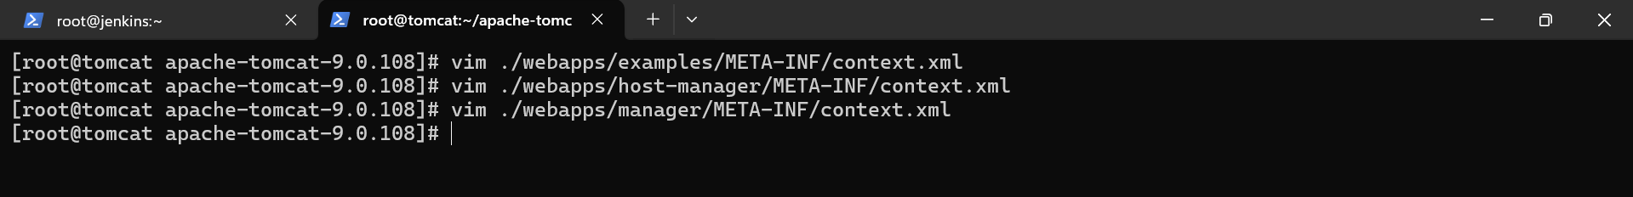

Added Tomcat server credentials in Jenkins.

Configured Jenkins to deploy builds on the Tomcat instance.

Triggered a successful Jenkins build and deployment to Tomcat.

Installed Docker on a new EC2 instance.

Configured Docker environment and verified installation.

Enabled root login and password-based authentication in both Docker and Jenkins servers.

Created SSH keys in the Docker node for secure connection.

Exchanged SSH keys between Jenkins and Docker nodes.

Installed the Publish Over SSH plugin in Jenkins.

Configured Docker node inside Jenkins system settings.

Created an IAM user in AWS with admin policy and generated access keys.

Configured AWS CLI on Docker instance using IAM access keys.

Set Jenkins to transfer files automatically to Docker after build.

It’s done

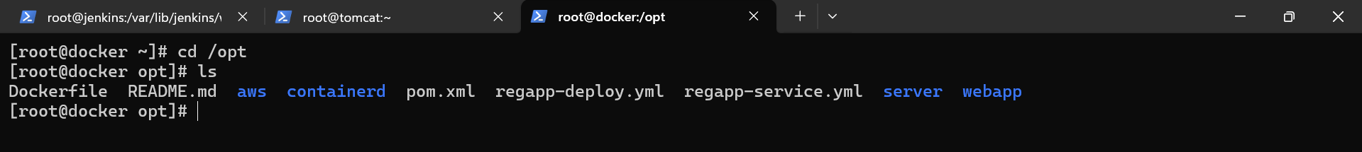

Automated creation of AWS Elastic Container Registry (ECR) through Jenkins.

Launched an EC2 instance for EKS setup and configured AWS CLI.

Installed eksctl and kubectl on the EKS node.

Established secure communication between EKS and Docker nodes.



Deployed an EKS cluster and added a node group.

Enabled root login and password authentication on EKS node.

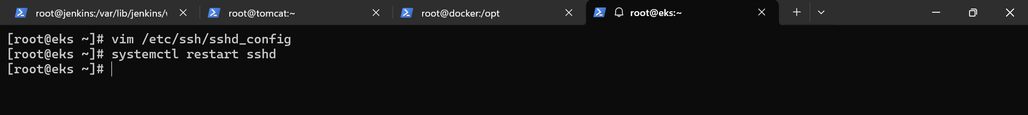

Transferred Kubernetes deployment and service YML files to the EKS instance.



Retrieved the ECR image URL.

Updated Kubernetes deployment file with the ECR image URL.

Added EKS cluster details inside Jenkins.

Configured Jenkins to deploy applications to EKS after build.

Ran kubectl get svc, copied external link, and accessed application on port 8080 via browser.

**By –**

**Asmit Kumar**